June 2012 | Test N : 6  7th form | Mark : __________________  20
Name : ----------------------------------------------------------------- Number : ------------------------ class : 7b -----
READING COMPREHENSION : (6pts)
Dear Catherine,
How are you? I’m fine in London, at the International School of English. I’m in class three with eight other students. They are all from different countries- Spain, France, Japan, Argentina, Switzerland and Thailand. Our teacher’s name is Peter Briscall. He is very nice and funny.
I am with an English family, the Browns. Mr. and Mrs. Brown have three children, they are all very friendly, but I can’t understand them well because they speak very quickly.
London is very big and interesting. The weather isn’t hot but sunny and the parks are beautiful! Hyde Park, Green Park and St James Park are all in the centre.
English food is OK but the tea is horrible. Write to me soon.
Yours Paola
Activity 1: Tick the correct alternative: (1pt)
Paola is studying French English biology

Activity 2: read the statements and write yes or No. (3pts)
- Pupils in Paola’s class are from Italy.  - The Browns haven’t got children.  - Paola likes the English food. | -------------  -----------------------------

Activity 3: Complete the sentences with the appropriate adjective from the list: (2pts)
strict / friendly / cold / delicious
- The Browns are -------------------------------------------
- The weather in London is -------------------------------

LANGUAGE: (8pts)
Activity 1: Look at the pictures and fill in the blanks with words from the box: (2.5pts)
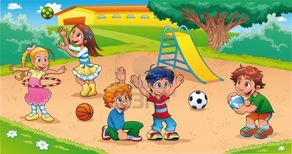 | 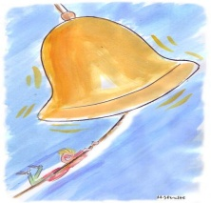 | 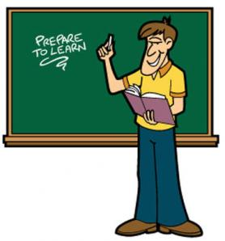 | 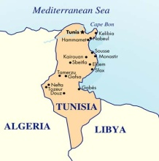
your / weather / clean / geography / map / garbage
It was 9.55 am. The pupils were playing in the courtyard. After ten minutes the bell rang and their 1) ----------------------teacher got into the classroom. He called the register then asked a pupil to 2) ---------------------the board. The lesson was about the weather so he opened a big 3) -------------------------and said :
-“what’s the 4) ------------------------------- like in Tunisia in winter?”
- “it’s rainy and cold” answered Ahmed.
- “that’s right but you must raise 5) --------------------------- hand to speak”.
- “I’m sorry Sir”

Activity 2: Match the sentences halves to get a coherent paragraph (there’s an extra part): (3pts)
- My favourite subject  - I like it because our teacher is  - He speaks calmly and  - He advices us  - He also says: “you must  - I never feel | - to practice sport regularly to keep fit.  - nice -looking and cheerful.  - tired or bored when I have a physical education lesson.  - is physical education.  - She is very serious.  - explains the activities well.  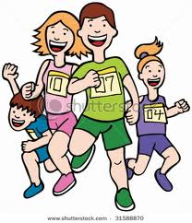  - have a balanced diet”.
(1 →---) (2 →---) (3 →---) (4 →---) ( 5 →---) (6 →---)

Activity 3: choose the correct alternative from the margin: (2.5)
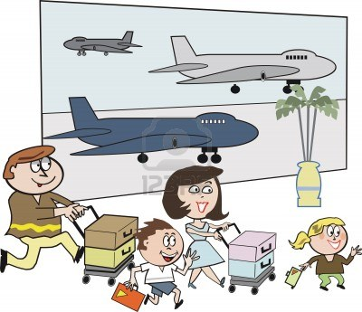 | Aunt margaret lives in Scotland. Last spring she 1)----------------------------------- us for a month. Everyday she 2)--------------------------with my mother to the shops to buy 3)------------------------. The last day she put her things in a 4)---------------and asked dad to drive her 5) ---------------------the airport. | - visiting / visited / visit  - goes / went / going  - souvenirs / shops / erasers  - bookcase / pencilcase / suitcase  - with / to / from

WRITING (6pts)

Activity 2: The topic of your school magazine is “how to keep your school clean” write some suggestions and advice. (These pictures may help you)
 | 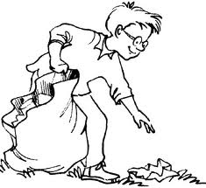 | 


